A White Paper on Strategic BPO in the US Healthcare Industry

The Current Healthcare Environment

The healthcare environment today faces challenges that it has never seen before. The industry is under attack from every possible direction from cost containment, HIPAA (Health Insurance Portability & Accountability Act) compliance, lack of stability, to an uncertain future. After trying various managed care techniques and concepts the onus to contain costs is now on the healthcare consumer.

Concepts such as defined contribution mutated into various consumer driven health plans are being touted as the nirvana pill for an aching industry. Medical and disease management is expected to play a key role for payors as they try to manage healthcare delivery. While executives are trying to grope for answers in an ever changing environment, the light at the end of the tunnel seems far away and a dim one at that. Regardless of the concepts that will or will not be around three years from now, one thing is certain, the degree of COMPLEXITY is increasing by the day.

Healthcare Payors are facing the following points of pain:
- Managing increasing medical costs and balancing customer satisfaction
- Reducing operating back-office costs
- Complying with HIPAA standards and requirements
- Upgrading IT infrastructure and moving to the web to provide real-time connectivity
- Focusing on survival and developing a strategy to differentiate products from other incumbents and new players
Value Chain vs. Value Chain Competition

The healthcare benefit administration value chain is unlike any other. While the manufacturing value chain is easy to decipher and understand, this one is as arcane to do so. The complexity coupled with the dynamism has given rise to multiple organizations offering very specialized services and working together to form the value chain. The final result of this complexity and specialization is multiple value chains which are heterogeneous in nature.

The value chain may be very tightly integrated (Eg. An integrated delivery system [IDS] ) or be very loosely coupled (Eg. As in the case of a self funded plan using third party services for major business functions). As a consequence of this, the consumable product the care received by the consumer, differs significantly. This difference is seen in two primary product characteristics. One being the choice currently available and the second is the quality of services received.

These value chains and their sub-systems have given rise to a situation where the competition is no longer between payors and health plans but true competition is between competing value chains. Hence the success of a particular healthcare organization will depend on the composition and efficiency of its value chain. Needless to say, this will have a significant impact on the delivery of care to the consumer.

The resulting competition in value chains will have a profound impact on the way healthcare organizations focus on strategy and healthcare delivery. Clearly, the increasing complexity too is a driving force for organizations to take a step back and reflect on core competency issues and ask fundamental questions about their business models. They are increasingly realizing that the original drivers for their existence in the past may no longer be applicable. Customer as well as consumer demands have changed. While the downturn in the economy has forced employers to evaluate the cost of group health benefits provided to employees, cost increases have also been influenced by changing dynamics in demographics and psychographics of the population (Eg. The aging of the baby boomers, Medicare cost shifting, etc.).

The emerging business model is hence going to be one where the healthcare organization is going to have to concentrate on those business functions which helps differentiate itself from competition and outsource those components which play a supporting role. This approach will allow it to effectively compete and survive in the industry.

Operational business functions that are expected to remain in-house and not be outsourced include:
- Provider Development & Contracting
- Benefits & Plan Development
- Actuarial Services
- Finance

Figure 1: The Healthcare Value chain.
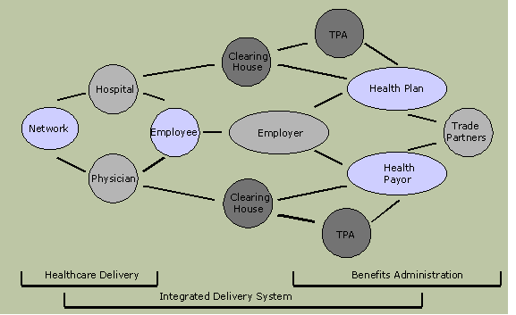
The role of the organization will hence be very specialized and one where it concentrates on few business functions that are core to its strategy and market segment. All other functions are outsourced. The health plan/payor will in essence control and drive the nature of the value chain and the quality of care received by the consumer. Organizations who adopt this philosophy will be nimble and quick to respond to market changes. This will result in the most efficient value chain and only those organizations with this built-in flexibility are likely to survive.
The Need for Outsourcing in Healthcare
A new study by the Gartner Group revealed that more than 50% of surveyed health insurers fully or partially outsource some of their IT/back-office business processes. This is up from 15% just a few years back.
Given the rate of change and the new challenges faced by the industry, the role of outsourcing within the healthcare value chain, is being further enhanced. A recent driver for outsourcing has also been HIPAA compliance. Many payor organizations and other covered entities have taken this opportunity to outsource some of their IT/business processes and have the vendor meet compliance requirements. As organizations move towards a strategy that focuses their effort on those aspects of its business model that are core to its strategy, they are increasingly finding that they cannot be bothered with the day-to-day issues that arise from non-core business functions.

This rationale has been the main driver for growth of ASP (Application service provider) & BPO services. The common question asked by all managers today is, What is our core competency and does that match with our internal operations? Business functions that do not align with this objective are being subjected to scrutiny to determine operational impact and value addition. Outsourcing results in middle management having only oversight responsibilities and thus freeing up most of its time for strategic planning and execution.
Figure 2: Top Reasons for Outsourcing
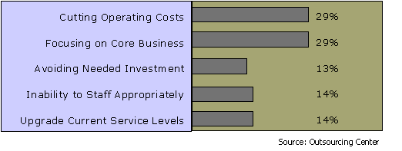

The flux in the industry has also attracted new players who bring with them a totally different paradigm. They have a strong read on the future direction that this industry is moving in and have the flexibility to adapt quickly in a changing environment. It is their business model that gives them this ability to be flexible. Traditional payor organizations with their excess baggage are finding it difficult to be nimble and are feeling threatened. They are also not able to keep up with the pace of technological change and find that their legacy systems are just not up to the challenge.

Given the inherent process intensive nature of the industry, outsourcing is and will become more and more important as plans/payors move towards concentrating their efforts on activities that help them differentiate from competition. These organizations are not only looking at pure ASP solutions for their IT infrastructure but are also pursuing BPO opportunities to help them become flexible and impact the bottom line.

"Outsourcing in the best sense allows companies to operate at a higher level of flexibility and at the same time see direct implications in cost reduction & revenue enhancement with a dramatic improvement in profitability."

The Role of Offshore Outsourcing in Healthcare

A recent sub trend in outsourcing is offshore outsourcing. Offshore outsourcing implies going to countries other than the US for these services. While this has become an important trend in core software and large application development (most large software companies in the US have dedicated development centers in India) it has also started to gather steam in the BPO segment. It is very likely that these BPO initiatives will move in the same direction as it has for the software industry.

Countries like India are recognizing this potential and are gearing up their infrastructure to attract organizations from the west to send manual & labor intensive work for processing. The other major driver for this is the vast difference in cost of labor between the east and the west. In most cases the offshore BPO vendor is able to hold labor costs at < - = of the rates in the US. Organizations are hence looking at this option as a near-term quick-hit opportunity. While this dynamic has existed in the past, the main impediment to this has been technology. Developing countries did not have the technology infrastructure in place to offer such services. This is rapidly changing and India in particular has taken the lead by ramping up telecommunications backbone to enable such initiatives. Satellite linkages, E1 ines, VPNs, etc., are easy to procure and setup.

More specifically, for the healthcare benefit administration segment, this is a great opportunity. Many of the non-core, manually intensive and high cost processes are now being outsourced to India. The government of India has also issued nineteen licenses to TPAs to offer health administration services. These organizations are gearing up to address the needs of the US healthcare industry and have developed expertise to do so.

The following are the key drivers and factors for growth in offshore BPO:

Globalization & Consolidation
As organizations become more global, they are looking at the most efficient, least cost operational model. Mergers & acquisitions also result in redundant back-office processes. The resulting rationalization process, often leads to business functions being consolidated and carried out at the lowest possible cost with the greatest efficiency. Sending back-office transactional functions (which typically do not add value from a business perspective) to countries like India enables them to streamline operations.

Reduce Back-Office Cost Further
Organizations who are already outsourcing business processes to other vendors in the US are investigating the possibility of reducing these costs further. BPO vendors in the US are tying up with other vendors in India and reducing their internal processing costs. The benefits are hard to ignore!!

Lower Labor Cost at Better Service Levels
Labor costs in India are substantially lower than those in the US. Hence an offshore BPO initiative results in savings that translate into shareholder value. Moreover, the workforce that carries out back-office processing is more qualified than its western counterpart, this results in higher service levels in terms of accuracy and productivity.

The Pervasive Nature of Technology
The Internet and advances in telecommunication have made it possible to open remote BPO centers half way across the globe. The operating environment is one which provides the same results as if processing was being done in one location and the customer does not notice any difference. The only physical difference, albeit a shrinking one, is that of geography.

Potential to Offer Multiple Choice to Clients
For existing BPO vendors & TPAs, having an offshore processing center or a tie-up with an offshore BPO vendor enables them to go back to their existing clients and offer the same services, with higher service levels and at a lower price point. Some of the larger players are already taking the first mover advantage by going this route. It is only a matter of time before the others follow.

